Sample MidTerm Questions

- Answer as True or False and justify your answer:

- A perceptron will converge for a linearly separable problem
T – as perceptron can learn any linearly separable function.

- Perceptron can learn X-NOR Gate

F – X-NOR gate is similar to XOR gate and it is not a linearly separable problem.

- The Backpropagation method is mainly based on Gradient Descent
F – Yes BP uses gradient descent BUT its main idea is to propagate errors back.

- Biological neuron uses step function as we use in Perceptron.
F – Biological neuron does not use step function (or other math function sigmoid in MLP). Artificial neuron uses some math functions trying to approximate the threshold function of biological neuron.

- Neural nets –
- Provide a schematic diagram of a simple perceptron neuron and describe mathematically its function. Give the Perceptron training algorithm in pseudo code. Does the Perceptron algorithm perform gradient descent? Justify your answer.

(to be done in class)
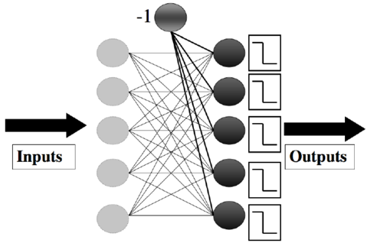
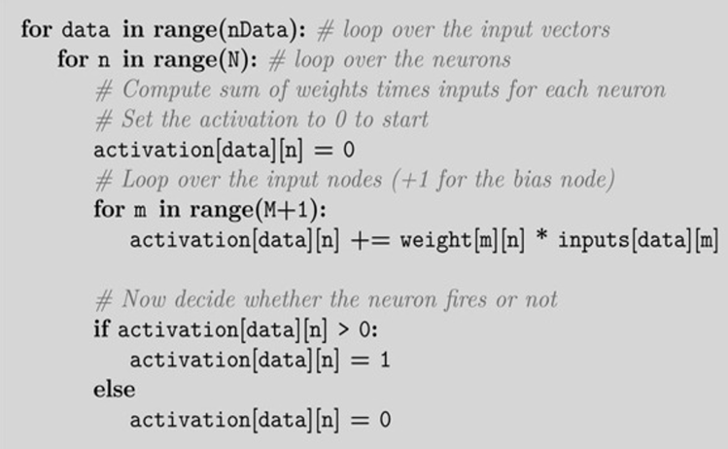

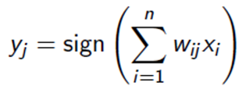

Mathematically, the function of a perceptron can be defined as follows:
y = f(w0 * x0 + w1 * x1 + ... + wn * xn)
The Perceptron algorithm does not directly perform gradient descent. Instead, it updates the weights based on the error between the predicted output and the target output. The weights are adjusted by a fixed amount proportional to the error and the input values. It can be viewed as a form of gradient descent, but with a simplified update rule that does not involve calculating gradients or taking steps in the direction of steepest descent. The Perceptron algorithm is specifically designed for binary classification tasks and can converge to a solution if the data is linearly separable.

- Explain the basic idea of the backpropagation learning algorithm. Explain the role of the learning rate: What effect has it when the learning rate is increased? What effect has a decrease of the learning rate?
Answer: Backpropagation performs gradient descent on the error function of the output neuron. i.e. it modifies the weights in many steps. Each step changing the weight in the opposite direction of the gradient, so as to move towards a (local) minimum of the error function.
The error can be determined for the output neuron(s), since the target output is known. However, the targets for the hidden layer neurons are not known. So, it is more difficult for the hidden layers. Backpropagation propagates back the error signal from the output unit(s) to the hidden units to create an equivalent error (delta at hidden layer) so that it is possible to change the weights of the hidden units also in order to reduce the error of the output units.
The learning rate determines the step size of each weight update towards the local minimum. If the learning rate is very small, a large number of updates are necessary. If the learning rate is large, the local minimum may be overstepped and possibly not found.

- Suppose that you multiply all weights and thresholds by a constant. Will the behavior of the network change?

- Consider a neural net with a step function threshold for the problem in question 4 above. Show all computations for back propagation of errors and weight adjustments. For Back Propagation of Errors (use the network shown in #2. Assume tk = [.7, .8] and sigmoid.

Ans. Ignore all the values within the circles in the output layer [the input values in the input layer remain same as in (a) i.e. 0.5 (left input neuron) and 1.0 (right input neuron). The same is true for hidden layer before using the sigmoid] as we are now going to calculate new values with targets as 0.7 for the left out put neuron and 0.8 for the right output neuron.

Now, let’s first do the forward pass:

Sum of inputs at the left hidden neuron = 0.5 x -1 + 1x0 = -0.5. Now, we need to use the sigmoid function to get the final output of left hidden neuron –

- Left hidden neuron -> 1/(1 + exp(-x) = 1/(1 + exp[-(-0.5)] = 1/ (1 + 1.60) = 0.384
- For 2nd neuron in the hidden layer, we have, 1/(1 + exp(-x) = 1/(1 + exp(-2) = 1/ (1 + .13) = 0.88
- For the 3rd neuron in the hidden layer, 1/(1+ exp (0)) ] = 0.50

- Hence, net input to the output neuron (left) = 2x0.384 + (-0.5x0.88) +0.5 = 0.768 – 0.44 + 0.5 = 0.828. Now, we take the sigmoid -> yk (left output neuron) = 1/(1 + exp(-.828)) = 0.69 and Target, Tk for this neuron is 0.7 as given.
- Now do the same for the right output neuron -> -2x0.384 + 0.88x1 + 0.5 x weight (0.5) = 0.362. Now take the sigmoid – 1/(1 + exp(-0.362) = 0.59. The Tk is 0.8 as given.

Now, let’s first do the backward pass: [Consider just the left hidden layer neuron.
First, we need to calculate delta at the out put layer neuron. For left out put neuron, we have
Equations to be used are:
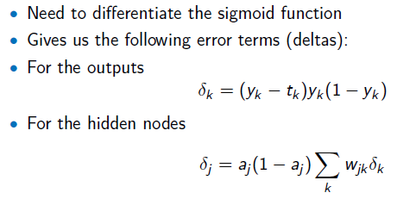
- Delta for left output neuron = (yk =0.69 – Tk = 0.7)x(0.69)(1-0.69) = -0.01x0.69x0.31 = -0.002
- For the right output neuron, it is (0.59 – 0.8)(0.59)(1-0.59) = -0.05

- Now, we can calculate back propagated errors to the hidden layer units. Let’s just do it for the left hidden layer unit:

- Using delta j equation shown above, we have, aj(1-aj).[(delta k at left output layer x weight = 2) + delta k at right output layer x weight = -2]. Note aj (as found before) is 0.384.

- 0.384(1-0.384).[(-0.002x2) + (-0.05 x -2)] = 0.022

Now we can use the weight update equation:

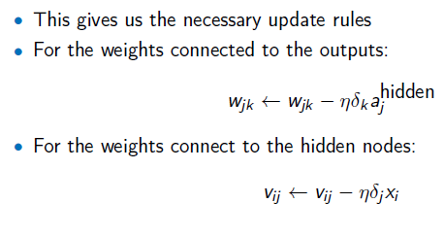
So, for the output layer weigh (between left output neuron and left hidden layer neuron), we have
New Wjk = 2 – eta (0.25).(-0.002 = delta k at left output layer).(0.384 = aj^{hidden})
= 2 + 0.00019 = 2.00019. Similar approach applies for all other weights.

- Why Machine Learning?

Ans: Key reasons are:
- Algorithms do not exist for many data driven applications (e.g. auto-driven cars).
- Algorithms may exist for some complex applications but they will take longer time to run and will be inefficient or less accurate.
- For large data (e.g. Big Data), the size of the data is too large and even if some algorithms may exist, it will be inefficient to use those.
- Automation of programming is very important to save time, improve accuracy and more. Automatically configuring / reconfiguring, or replacing some blocks that might be learned by an ML method are good list for automation using ML.

- Dimensionality Reduction – Concept (LDA, PCA)

- Some key issues: training, validation, testing, learning parameters, VC Dimension

- Feature Engineering: Definition, Types, Domain knowledge / relationship between features, math based transformations etc

- Q & A

